APPLY TO FULLSTACK

Fullstack's admissions process takes about 2-3 weeks from application to decision. Admissions are done on a rolling basis, so the earlier you apply, the better. This is a common application across all Fullstack programs (New York, Grace Hopper New York, Chicago, Grace Hopper Chicago, Flex, and Summer of Code). Acceptance into one program is transferrable to other programs that fit your needs.

Please see our [admissions page](https://www.fullstackacademy.com/admissions) for further details on the process.

**Spots are limited for the next Fullstack cohort - Apply today to secure your place.**

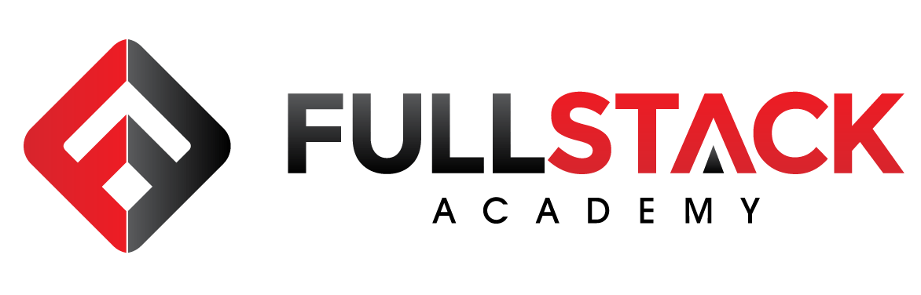



* [1](https://www.fullstackacademy.com/apply?utm_campaign=ThankUNext&utm_source=hs_automation&utm_medium=email&utm_content=69837950&_hsenc=p2ANqtz-81UFckoU856sAvZSuI1V9OxBoauNfzspUSnlFdf2kqbmAqDHCFZu6YUKY8d4Yvr6GJbtJWZi1ia-FrNvUxM78bLcG0-A&_hsmi=69837950#ptab1)

APPLICATION SUBMISSION

* [2](https://www.fullstackacademy.com/apply?utm_campaign=ThankUNext&utm_source=hs_automation&utm_medium=email&utm_content=69837950&_hsenc=p2ANqtz-81UFckoU856sAvZSuI1V9OxBoauNfzspUSnlFdf2kqbmAqDHCFZu6YUKY8d4Yvr6GJbtJWZi1ia-FrNvUxM78bLcG0-A&_hsmi=69837950#ptab2)

ASSESSMENT

* [3](https://www.fullstackacademy.com/apply?utm_campaign=ThankUNext&utm_source=hs_automation&utm_medium=email&utm_content=69837950&_hsenc=p2ANqtz-81UFckoU856sAvZSuI1V9OxBoauNfzspUSnlFdf2kqbmAqDHCFZu6YUKY8d4Yvr6GJbtJWZi1ia-FrNvUxM78bLcG0-A&_hsmi=69837950#ptab3)

ONE-ON-ONE INTERVIEW

* [4](https://www.fullstackacademy.com/apply?utm_campaign=ThankUNext&utm_source=hs_automation&utm_medium=email&utm_content=69837950&_hsenc=p2ANqtz-81UFckoU856sAvZSuI1V9OxBoauNfzspUSnlFdf2kqbmAqDHCFZu6YUKY8d4Yvr6GJbtJWZi1ia-FrNvUxM78bLcG0-A&_hsmi=69837950#ptab4)

ADDITIONAL INTERVIEW (DISCRETIONARY)

* [5](https://www.fullstackacademy.com/apply?utm_campaign=ThankUNext&utm_source=hs_automation&utm_medium=email&utm_content=69837950&_hsenc=p2ANqtz-81UFckoU856sAvZSuI1V9OxBoauNfzspUSnlFdf2kqbmAqDHCFZu6YUKY8d4Yvr6GJbtJWZi1ia-FrNvUxM78bLcG0-A&_hsmi=69837950#ptab5)

**DECISION**

Step 5: We deliver an admissions decision to you and talk about next-steps.

Top of Form

FIRST NAME*



LAST NAME*



EMAIL*

SKYPE ID*



MOBILE PHONE NUMBER*(No special characters between numbers: (15554443333)

GENDER IDENTITY*

* FEMALE
* MALE
* PREFER NOT TO IDENTIFY

ARE YOU 18 YEARS OF AGE OR OLDER?*

* YES
* NO

ARE YOU A MILITARY VETERAN OR ACTIVE MILITARY PERSONNEL? *Veterans and active military qualify for an automatic $1000 Scholarship.

* NO
* YES

STREET ADDRESS*



CITY*



STATE/REGION*



POSTAL / ZIP CODE*



ARE YOU CURRENTLY AUTHORIZED TO WORK IN THE US?*

* YES
* NO

COUNTRY OF ORIGIN*

* USA
* OTHER

WOULD YOU CONSIDER YOURSELF AN INTERNATIONAL STUDENT?*

* NO
* YES

COHORT PREFERENCES: DATES & LOCATION

WHICH FULLSTACK PROGRAM IS YOUR 1ST CHOICE?*



WHICH FULLSTACK PROGRAM IS YOUR 2ND CHOICE? (IF APPLICABLE)



NYC WEB DEVELOPMENT FELLOWSHIP

Please make sure to read about the details and eligibility restrictions of this program [here](https://docs.google.com/document/d/1r_wm7JEAaTnA-StB1kQd5QbiFSeoS7z-uXm80MWwO1Y/edit?usp=sharing).

(If you are interested in applying for the NYC Web Development Fellowship, please select "Full-Time Immersive Cohort - New York" as your first choice program preference)

ARE YOU APPLYING TO THE NYC WEB DEV FELLOWSHIP TRACK?If yes, you'll be required to answer the questions that will appear below.

* YES
* NO

**LINKS**

LINKEDIN URL *



GITHUB URL (OR ANY OTHER SOURCE CONTROL USED)



ANY OTHER LINKS WE SHOULD LOOK AT? FEEL FREE TO EXPLAIN.Have a website or blog? Twitter or Tumblr? If you've already worked on projects, give us links and tell us what part of the project you built.



EDUCATION

WHAT IS THE HIGHEST LEVEL OF EDUCATION THAT YOU HAVE COMPLETED?



ADDITIONAL INFORMATION ABOUT YOUR EDUCATIONAL BACKGROUNDLet us know anything else that would help us understand your background. We're specifically looking for people with the ability to think critically and analytically. You can include things like standardized test scores, awards, experiences, etc.



WHAT HAVE YOU TRIED SO FAR IN LEARNING TO CODE?*



WHERE WOULD YOU PLACE YOURSELF IN YOUR "ROAD TO CODE"?*



WHAT CODING LANGUAGE DO YOU HAVE THE MOST EXPERIENCE WITH?



EMPLOYMENT HISTORY

HAVE A RESUME?

EMPLOYMENT STATUS*



EMPLOYMENT HISTORYTell us more about each position you've held in your employment history. How did you get where you are?



POST-FULLSTACK PLANS

WHAT WOULD YOU LIKE TO DO AFTER GRADUATING FULLSTACK/GRACE HOPPER?*



TELL US MORE ABOUT YOUR CHOICE ABOVE, OR ANYTHING MORE ABOUT YOUR PLANS AFTER FULLSTACK/GRACE HOPPER



WHY DO YOU THINK FULLSTACK/GRACE HOPPER IN PARTICULAR WILL BE A GOOD FIT FOR YOU?*



WHY WOULD YOU BE A GREAT STUDENT AT FULLSTACK/GRACE HOPPER?*



WHAT HAVE YOU TAUGHT YOURSELF IN THE PAST YEAR?*



ANYTHING ELSE ABOUT YOU WE SHOULD KNOW?What differentiates you as a candidate?



DO YOU HAVE FEEDBACK ABOUT OUR WEBSITE?What did you like and what can we do better?



WHAT COMMUNITIES DO YOU FOLLOW ONLINE?(Newsletters, podcasts, blogs, etc.)



HOW DID YOU HEAR ABOUT FULLSTACK/GRACE HOPPER?



URL OR MORE ABOUT HOW YOU HEARD ABOUT FULLSTACK/GRACE HOPPER



All applicants are bound by our Applicant Code of Conduct. Please read it [here](https://www.fullstackacademy.com/admissions-code-of-conduct).

* YES, I AGREE TO THE APPLICANT CODE OF CONDUCT*

Bottom of Form